Task 2
Name: Raahima Rashid Peracha
Department: Software Engineering
Class: Data Science 3-A
Subject: Artificial Intelligence (LAB)
Instructor: Sir Rasikh Ali
LAB 2 TASK:
Fizz Buzz
- To create this FizzBuzz game first of all I have imported random to the coe so that the computer can guess a random number.
- Then I have printed a welcoming message.
- After that I have used the while loop(It was not necessary to use it but I wanted to .)
- After that I have used If-elif-else condition to check if the number is divisible by 5, 3 or both or else the prayer will be eliminated and the game will end.
- After that I have used break to end the loop or else it would never end.

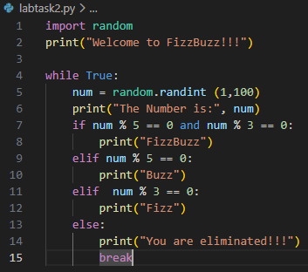
INPUT:

